UK Dynamism Update CEP Occasional Paper

- Introduction

A dynamic economy is one in which resources can move flexibly to their most productive use. It is also an economy whereby entrepreneurs and innovative new ideas can succeed.

The UK economy, like others internationally, has seen a long-term decline in measures of dynamism. Previous work has found _

Businesses in the UK have been subject to an exceptionally turbulent environment since the start of the COVID-19 pandemic in 2020. Natural market forces, that may have led to substantial exit of firms, were temporarily paused through government support designed to keep firms afloat and workers employed. As government support was withdrawn throughout 2022, firms were once again subject to market forces with less resilience after the effects of the pandemic.

We provide an overview of dynamism in the UK economy since the pandemic, using administrative data on registered firms.

- Data

Increasing use of administrative data in the UK.

  - Business Structure Database

The Business Structure Database is our main firm-level data source. It is made up of annual snapshots of the Inter-Departmental Business Register (IDBR), taken in March each year. The IDBR captures all companies registered for either Value Added Tax (VAT) or Pay-As-You-Earn (PAYE). The turnover threshold for VAT is £90,000, as of 1 April 2024. Any company employing a full-time member of staff will be registered for PAYE. Despite covering only __% of the total business population, these firms cover __% of employees. This broad coverage makes the dataset useful for

Entry and exit are defined as

 | t-1 | t | t+1
Entry | Not active | Active | Active
Incumbent | Active | Active | Active
Exit | Active | Active | Not active

  - Alternative UK microdata sources

In recent years the ONS have developed the Longitudinal Business Database, also utilising IDBR snapshots. [CITE LBD USER GUIDE]

Comparison of BSD vs LBD

LEED

Companies House (real time)

- New activity; entry and expansion

New jobs, new businesses and new ideas are all traditional metrics of a successful economy.

  - How many firms are entering?

The entry rate captures the number of firms starting to trade as a share of the business population. In 2021 the entry rate slowed to 13.4%, the lowest level since 2011. By 2022 it had increased to 14.3% but remained below the average of 15% seen between 2011 and 2018.

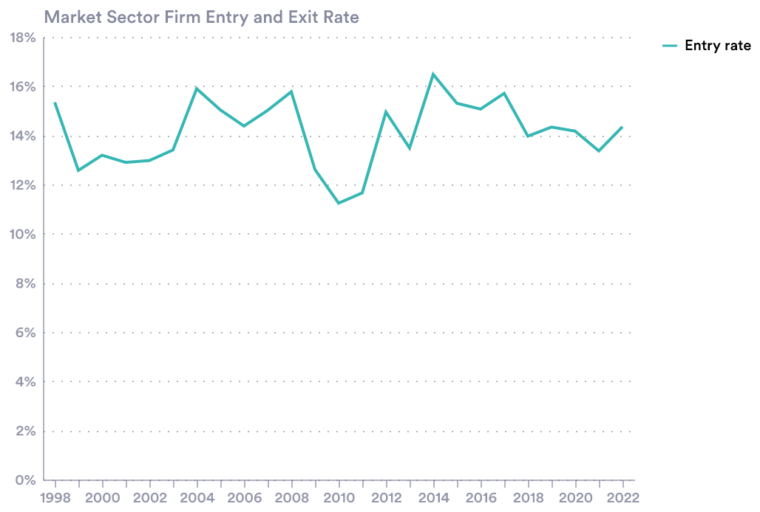

Most firms entering are small. Less impactful for employment but important for innovation.

What industry were entering firms in?

Evidence from other data sources suggests there was an increase in firm entry during the pandemic, particularly for small businesses.

Pandemic-surge in small business formation (Savagar, Piton, Bahaj 2024) (Decker, Haltiwanger 2023)

Survival rates of firms entering in 2020 and 2021 compared to pre-pandemic period.

  - Are successful firms able to expand?

Although new businesses are important for innovation, the ability for existing, successful businesses to expand is arguably more vital for productivity growth.

[JOB CREATION BY INCUMBENTS]

[Average number of jobs created by an incumbent firm]

Medium and large firms stopped creating jobs in 2021.

Aside from simply increasing their number of employees, firms can expand through opening new physical locations. Since 2010, firms are opening substantially fewer sites.

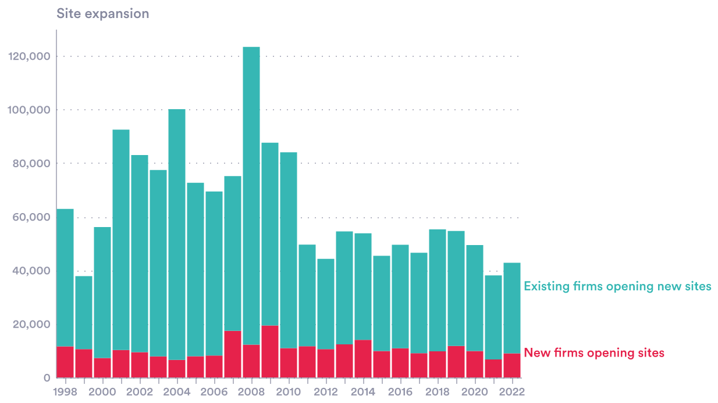

In this data export I didn’t include total site count so unable to produce site expansion RATES, but will be able to update with this.

By nature, firms operating in certain industries are more likely to have more than one physical location. Retail, for example, has traditionally required outlets nationwide to serve local markets. Professional services companies, meanwhile, are more likely to have staff concentrated in a few office locations.

Why might have firms stopped opening new sites
- Structural changes away from operating multiple sites, digital technology enabling access of markets without physical presence

In the US patterns of geographical expansion have been documented (Industrial revolution in services).

Responsiveness of employment growth to firm’s own productivity. Are successful, productive firms expanding or staying the same size? If not expanding, why not?

- Calling it a day

The other side of dynamism, often overlooked, is the exit of unproductive firms.

Continuous establishment of new businesses and growth of existing ones can only take place up to a point, that point being the resource limit of the economy. Considering labour as a resource, 34.19 million people were in employment in the UK as of July-September 2025. Given ‘full employment’, implied by an unemployment rate of 4-5%, the scope for a larger workforce is limited. This makes effective use of labour even more important.

How do we determine beneficial exit versus damaging exit?

4.1 Exit rates

  - Retrenchment

- A labour market focus

An increasing frequency of job moves is a positive sign of dynamism. The proportion of workers starting new jobs reached an all-time high following the pandemic, exceeding 3% towards the end of 2021 and throughout 2022.

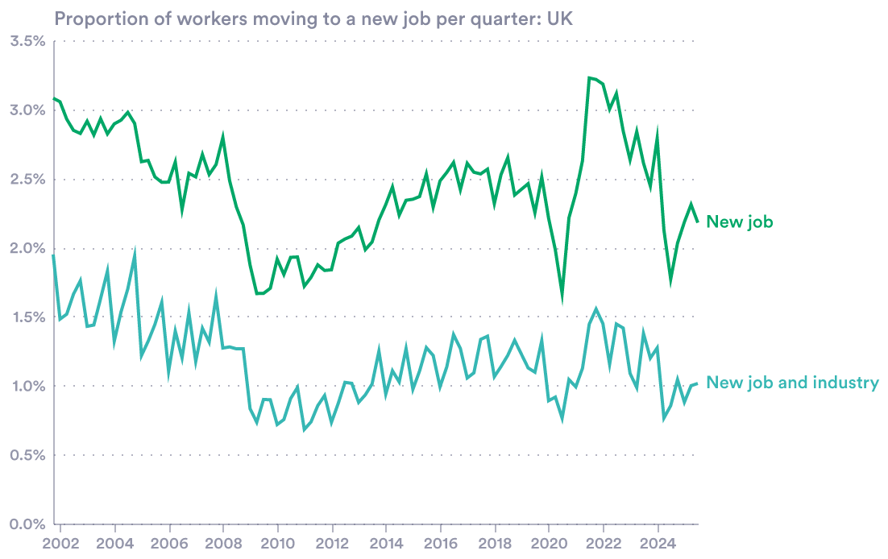
Source: ONS X02 Labour Force Survey Flows estimates

Is LFS data reliable to use for this period?

Bibliography

